Computer Programming
BSCS [1-A]
FINAL TERM PROJECT REPORT



Submitted By [Group No. 1]:
- Mamoon Akhter (Leader)
- Farquleet Ahsan
- Abdullah Khalid
- Muhammad Abdullah
- Feeman

Submitted to: Lab Instructor Name

PROJECT NAME
JOB WALE

DEPARTMENT OF COMPUTER SCIENCES
BAHRIA UNIVERSITY, LAHORE CAMPUS

Table of Contents
Marks Distribution 3
Abstract 4
1. Introduction 5
2. Database Design 5
3. Problem Statement 5
4. Objectives 5
5. Results 5
6. Screen Shots of Final Product 5
7. References 5

INTRODUCTION
Welcome to our advanced Job Portal, crafted for seamless job hunting and efficient recruitment. With five intuitive options, our portal ensures a smooth user experience:
- Create a New Company:
Register your company effortlessly, providing essential details to make your job opportunities visible to potential applicants.
- Add Details for Your Company:
Enrich your company profile by supplying additional information, showcasing your culture, values, and unique offerings to attract top talent.
- Apply for a Job:
Job seekers can effortlessly submit applications to registered companies, streamlining the job application process.
- Display Available Companies:
Explore diverse job opportunities by accessing a comprehensive list of registered companies aligned with your career goals.
- Exit:
  - Conclude your interaction seamlessly. Clicking "Exit" ensures a smooth exit from the program.

DATA BASE
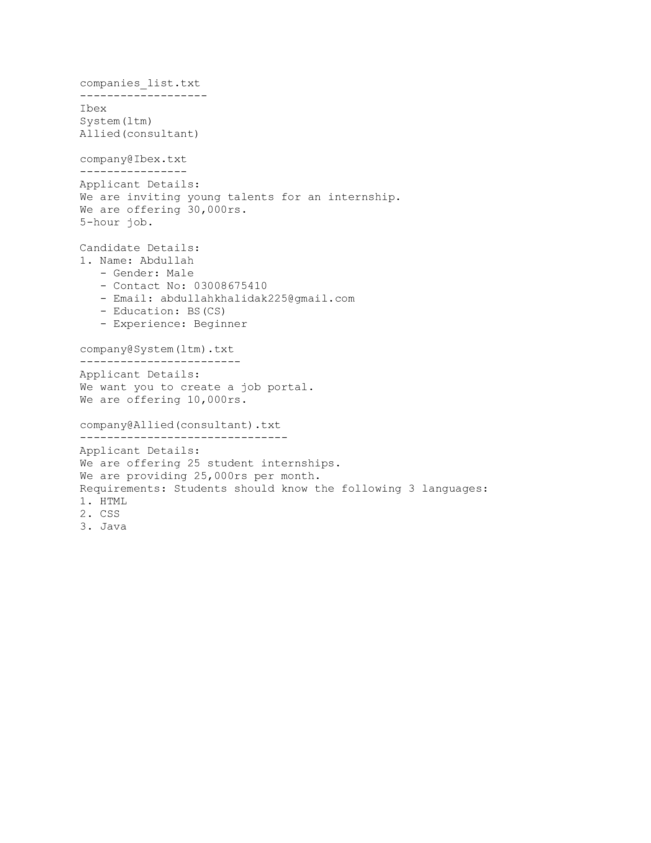

PROBLEM STATEMENT
We make this project of job platform for help job seeker to get job easily.We make this project in a way that user can understand easily and our code is simple anyone can uderstand it.
OBJECTIVE
- Create an easy-to-use platform for job seekers to find jobs that match their skills, qualifications, and preferences easily.
- Help companies display their job openings, company culture, and values to attract suitable candidates.
- Simplify the job application process for candidates, making it easy to apply for multiple positions using a standardized application format.
- Offer job seekers educational resources, career advice, and industry insights to assist them in making well-informed career decisions.

RESULTS
Home page
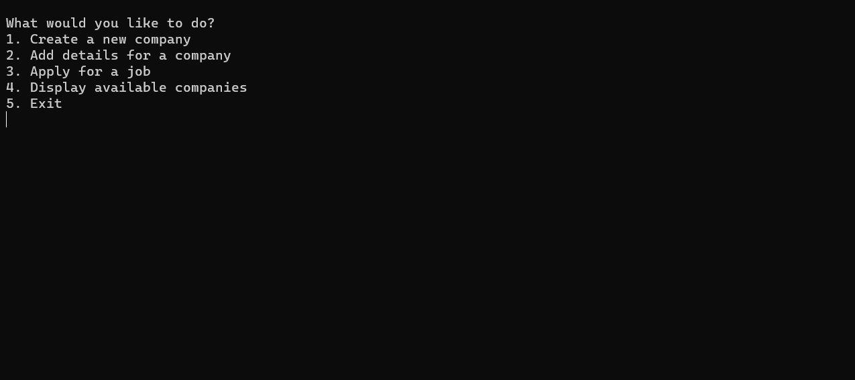
Company creation and detail

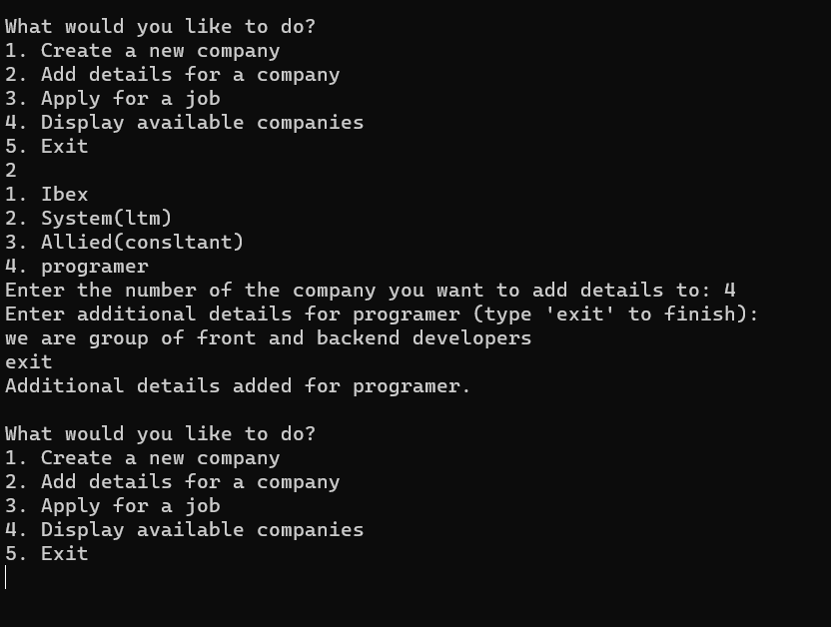
Available Companies
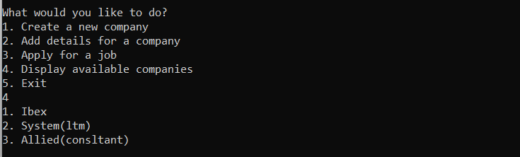

CANDIDATE DETAIl
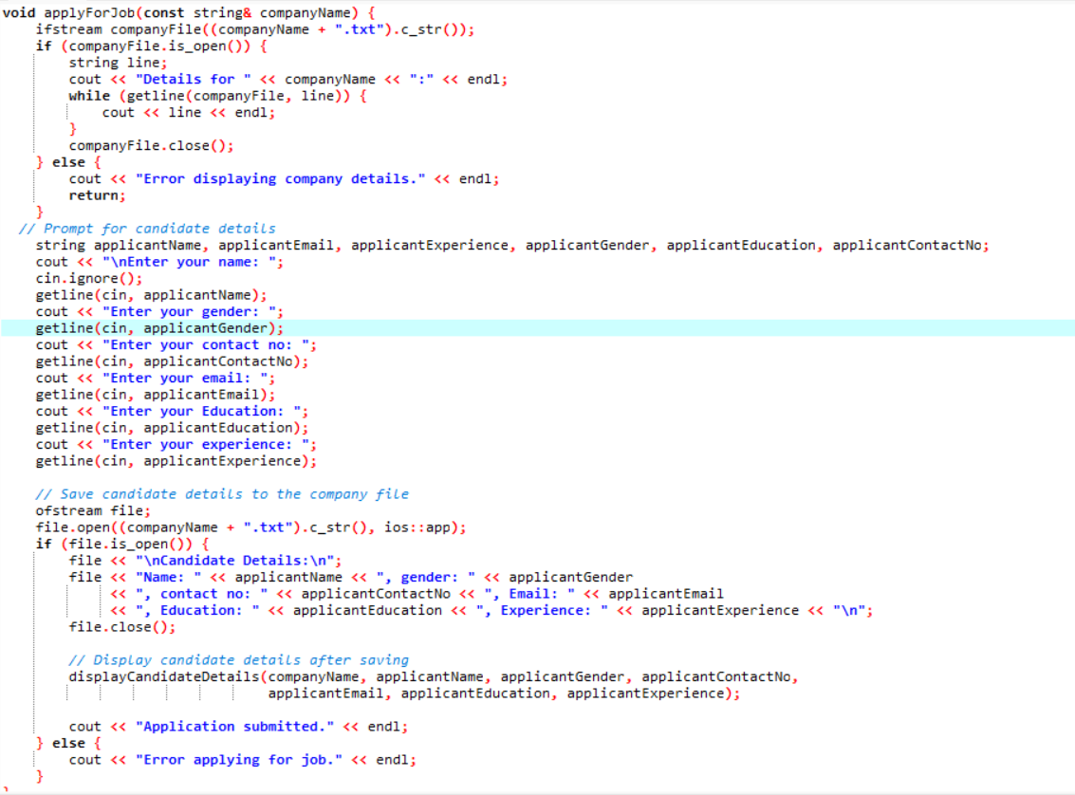
- Code for display candidate detail
void displayCandidateDetails(const string& companyName, const string& applicantName,
const string& applicantGender, const string& applicantContactNo,
const string& applicantEmail, const string& applicantEducation,
const string& applicantExperience) {
cout << "\nCandidate Details for " << companyName << ":" << endl;
cout << "Name: " << applicantName << "\nGender: " << applicantGender
<< "\nContact No: " << applicantContactNo << "\nEmail: " << applicantEmail
<< "\nEducation: " << applicantEducation << "\nExperience: " << applicantExperience << "\n";
}

Components use in Program
- Libraries
- #include <iostream>
- #include <fstream>
- #include <vector>
- #include <string>
- Structure (for company and candidate)(in global)
- Switch case(5 cases)
- File handling(to save and create file)
- Functions( display company ,create company , applicant details and display applicant details)

REFRENCE:
- Presenting "Job World" – a revolutionary job portal inspired by Jobee's user-centric model. With an intuitive interface, smart matching algorithms, and mobile accessibility, Job World optimizes the job search process. Our innovative application system, emphasis on company culture insights, and robust security measures echo Jobee's influence. Committed to continuous improvement, Job World aspires to redefine industry standards, offering a seamless and informed experience for job seekers and employers alike.

Marks Distribution
------------------------------ For Instructor Use Only ----------------------------------
Project Grading Sheet
Sr. No. | Task | Max Marks | Obtained Marks | Comments(if any)
1. | Report | 2.5
2. | Implementation | 12.5
3. | Viva  (Oral/Task Based or Both) | 5
Total |  | 20 |  | Signature:
---------------------------------------------------------------------------

Abstract
This section contains the initial impression/summary of your project. This part speaks for report. This section should present the actual meaning of the project topic, should summarize the need of this project, the hypothesis, objectives and procedure that is followed to accomplish the defined objectives.
Though this paragraph appears first but is edited in the last as it’s the concise summary of the project.

Introduction
This section provides a description of the basic facts and importance.
What is your project is, the motivation of doing this project, and how important is it for the industry practice/knowledge advancement

Database Design
Paste your database design here in this area. Database Design can be Downloaded and copied from SQL-Server Database Design portion.

Problem Statement
Problem statement provides a clear and concise description of the issues that need to be addressed.
What is the specific problem that you will solve by implementing this project? [Write in bullets/2 to 3 line para]

Objectives
Objectives provide a list of goals that will be achieved through this project.

Results
This section defines the methods and logic steps.
What to do and how to solve the problem and achieve proposed objectives? Which methods will be used? Attach a project schedule table, if necessary.

Screen Shots of Final Product
[Assign number to each figure].

References
All the factual material that is not original with you must be accompanied by a reference to its source. List down all the helping links that you used to implement your project.

